**SmartVA Auto Analyse Version 2.0**

**User Guide**

Table of Contents

Introduction 3

Pre-requisites 3

Installation 3

Download the file 3

Run setup 3

Configuration File – Configuring for your environment 8

Opening the File 8

Settings 9

Tablet Configuration 11

Developer Mode 11

Running for the first time – USB connected device 12

Program Outputs – What does it do 13

Screen Output 13

File Outputs 14

Results.csv 14

Log Files 15

log.txt 15

adblog.txt 15

BriefcaseOutput.txt 15

TariffOutput.txt 15

SmartVA Auto Analyse User Guide

## Introduction

This program has been designed to allow the Cause of Death (CoD) to be determined automatically, once an entry or entries have been completed on an Android tablet using the ODK Collect application. It utilises ODK Briefcase and the SmartVA application to do this.

## Pre-requisites

For the successful running of the auto-analysis, there are a number of pre-requisites that must be met.

* Windows 7 or newer operating system (Mac not supported)
* Windows Powershell 2.0 or greater must be installed on your system. This should already come installed with Windows, however it is noted here for completeness should you experience any issues with running the program.
* Java JRE is required to run the ODK Briefcase component. If this is not installed then you will be notified when you run the program for the first time. To install the latest version of Java JRE, head to <https://www.java.com/en/download/> and install this.

## Installation

### Download the file

To begin, download the setup file from:

### <https://cloud.mdhs.unimelb.edu.au/index.php/s/tddX2LAnlWzvoi8>

### Run setup

Once the download has completed, close all open programs and run the setup file.

Click **Next** to continue

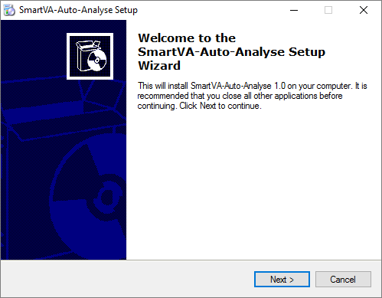

Read the License Agreement and click on **I accept the agreement** if you agree to the license and wish to continue installing. Click **Next**.

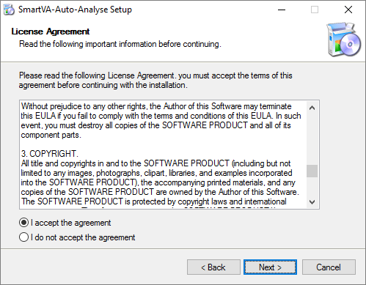

To continue with the default install location click **Next**, otherwise choose where to install the program by using the **Browse** button.

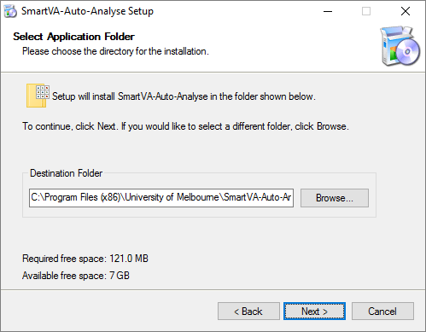

Click **Next** to continue with the defaults.

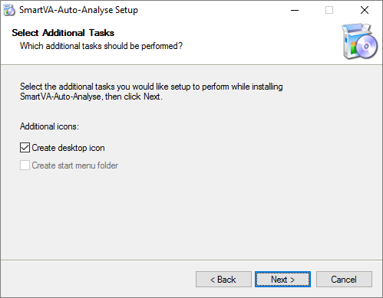

The Android Debug Bridge (required to communicate with the Tablet) installer will launch. Answer ‘**y**’ to each question to have the ADB component and driver installed.

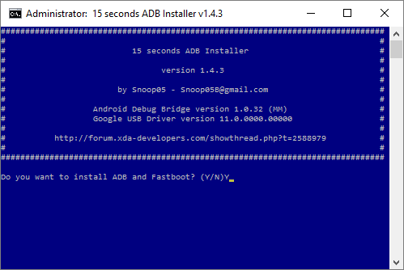

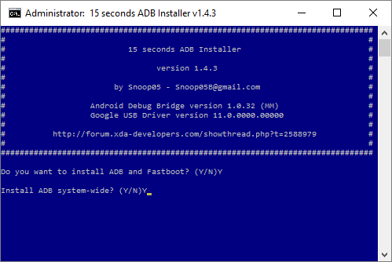

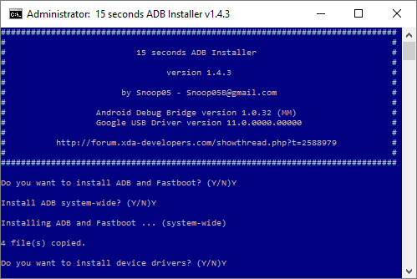

The device driver installation wizard will now run. Click **Next.**

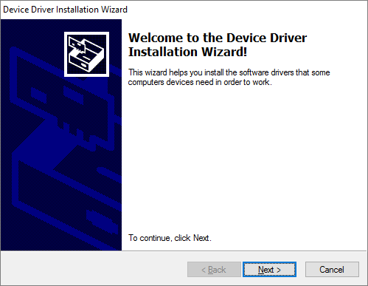

You may see a warning like the one below. Click **Install**.

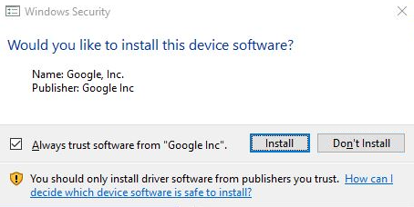

Click **Finish** to complete the ADB Driver installation and return to the program installation

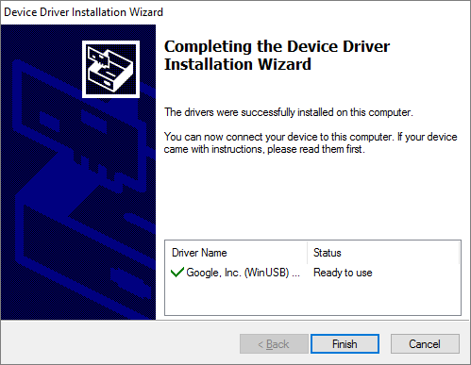

Finish the program installation by clicking **Finish**. This will reboot your computer and finalise the installation of drivers and other components.

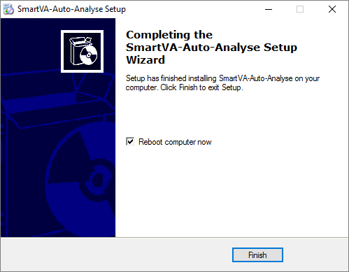

## Configuration File – Configuring for your environment

### Opening the File

This program uses a configuration file to allow particular settings to be changed. These will need to be reviewed prior to running for the first time, and set appropriately for your implementation. Any changes will be reflected when the program is next run. To view and edit this file, you need to open the file in Notepad as an administrator. To do this, perform the following:

* Open your Windows start menu, search for the notepad application and then **right-click** the notepad icon.
* Choose “**Run as administrator**”
* Select **Open** from the **File Menu**, andbrowse to the folder that contains the configuration file ‘**config.txt**’. This will be **C:\Program Files (x86)\University of Melbourne\SmartVA-Auto-Analyse** for a default installation.

The file should now be open for editing and look as follows:

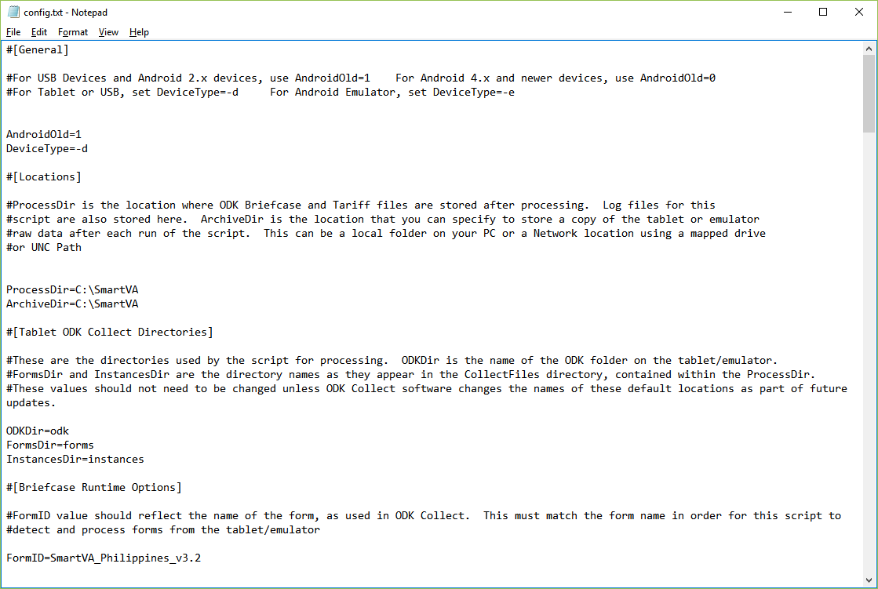

### Settings

There are a number of settings in this file, each grouped under specific headings. Each of the headings and configuration options are explained below. Note that 0=Off/No and 1=On/Yes for applicable settings.

**[General]:** This is the general section that is used to define general program settings

**AndroidOld:** If you have an older Android device running version 2.x, or if you are accessing data stored on a USB drive, then set this value to ‘1’. This will prevent the program from trying to access the device via ADB and will use the USB Mass Storage method of obtain files. If this setting is set to ‘0’, then the program will assume a newer Android device is connected and will use the installed ADB drivers (with tablet in Developer Mode) to pull data directly from the tablet.

Default value: 0

**DeviceType:** This setting allows you to specify if you are running a physical device or an emulator (such as MEmu or Bluestacks). For a physical device, leave this setting as ‘-d’. If using an emulator, set this to ‘-e’. Note: the AndroidOld setting should be set to ‘0’ for this to work.

Default value: -d

**[Locations]:** This section contains settings related to file locations for use with the program

**ProcessDir:** This is the ‘working directory’ for the program and is where the program will store many of the files used to process your results. Note that the results.csv output file and also all archived information will be stored in the Archive directory (see ArchiveDir setting below). This directory also contains the Tariff output files that you would usually find in the TariffFiles sub-folder. Note that these are cleared each time the program runs and only the predictions and csmf Tariff outputs are kept (stored in the archive folder also).

Default value: C:\SmartVA

**ArchiveDir:** This is the ‘archive directory’ for the program. This directory is used to store a copy of files found on your tablet after processing. If there are any errors with Tariff processing, the program will copy the tablet files to an ‘Errors’ subfolder which can then be reviewed at a later date. Any files copied to the Archive can also be used to process results manually, using ODK Briefcase and SmartVA software. If SmartVA-auto-analyse is successful in processing your Tablet files, a copy of these will be placed under the ‘Processed\Forms’ subfolder and ‘Processed\Instances’ subfolder. Only the latest version of any given form or instance is maintained in the archive to prevent duplicates of raw data, and to ensure any changes in VA data are captured in the archive (such as a form/VA that is edited AFTER having already run this program).

It is possible to set this value to either a drive location or a UNC path, and therefore can be used to store the Archive on a network drive or location that can then be backed up and retained overtime (recommended). If this Network location is used for all computers running this program, then their data will be aggregated into the archive, creating one full dataset with associated form(s). Refer to your IT support team to determine if this option is available.

Default value: C:\SmartVA

**[Tablet ODK Collect Directory]:** This section contains settings related to the ODK Collect application directory

**ODKDir:** This setting should reflect the name of the odk folder as used by ODK Collect on the device. The current version of ODK Collect uses the directory ‘**odk**’. Should the directory name change with future ODK Collect versions, this setting can be updated to ensure the program will continue to function correctly.

Default value: odk

**FormsDir/InstancesDir:**  FormsDir and InstancesDir are the directory names as they appear in the CollectFiles directory, contained within the ProcessDir as set above. These values should not need to be changed unless ODK Collect software changes the names of these default locations as part of future updates. Default values: FormsDir=forms, InstancesDir=instances

**[Briefcase Runtime Options]**: This section is used to define the runtime options for ODK Briefcase.

**FormID:** The name of the form in use is required by ODK Briefcase in order to export the correct information. Once a form has been uploaded to an Android device for use with ODK Collect, the form name should also be updated here to allow the automated processing of any entries created. ***This setting is case-sensitive and needs to match the exact name of the form as seen in the device.***

Default value: PHMRC_Shortened_Instrument_8_20_2015

**[Tariff Runtime Options]:** As with ODK Briefcase, the SmartVA-CLI application requires certain parameters in order to analyse and produce results. These parameters are set in this section.

**country:** A 3-letter abbreviation representing the country that the data originated from. Note that all valid country abbreviations are listed at the bottom of the configuration file for easy reference.

Default value: unknown

**hiv:** This setting is used to indicate if this is an HIV region. Set to ‘0’ for no, and ‘1’ for yes.

Default value: 0

**malaria:** The user must determine whether malaria is a possible cause of death in the population from which the VAs were collected. If this the box next to “Malaria region” is not selected, the Tariff Method will not assign malaria as a cause of death. Set to ‘0’ for no, and ‘1’ for yes.

Default value: 0

**hce:** This setting relates to Health care experience variables. The user should determine whether, as part of the survey, questions regarding the health care experience (HCE) of the deceased or his/her family are asked. If the setting for hce is set to ‘0’, these variables are not included in the analysis, and the software will use appropriate training data which are not enhanced with HCE variables.

Default value: 1.

**freetext:** If your data has an open response component and you would like this to be analysed by the Tariff Method, make sure this setting is set to ‘1’.

Default value: 1.

**figures:** This setting allows you to specify if Tariff figures are to be generated or not at run-time. As this requires more processing time and overheads, this is turned off by default. Set this value to ‘true’ to have figures generated, or ‘false’ to omit these figures when running the program.

Default value: false

## Tablet Configuration

### Developer Mode

All Android devices running version 4.x and above will need to be configured to turn on Developer Mode to allow the program to access the ODK Files on the tablet via USB cable.

***Note: Unplug your tablet from the PC BEFORE you enable these settings and ensure you have restarted your PC.***

Each tablet will have slightly different methods to achieve this, but most of the newer devices will have a **Developer Options** area in the **Settings** of the device.

Go into ***Settings->Developer Options*** and ensure that Developer Mode is turned on, and that USB Debugging is also enabled.

The below is an example from a Samsung Tablet.

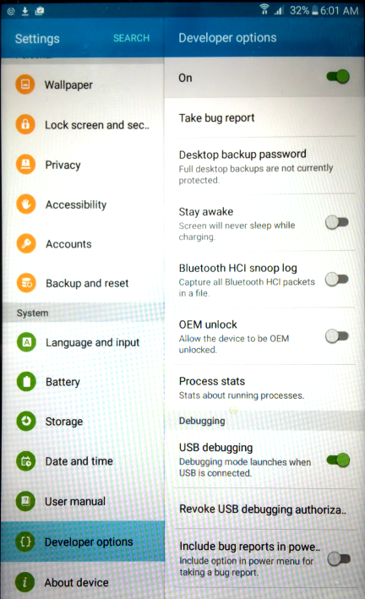

Once you have enabled this, plug the device into your PC/Laptop with the USB Cable. You should be prompted to allow USB debugging from your PC.

Select **‘Always allow this computer’** and press **OK.**

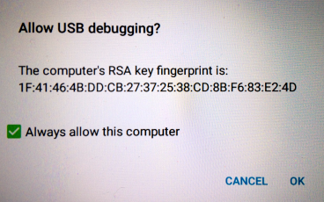

Your tablet is now connected and ready to run the program. These steps are only required once and in future you can simply connect the device and run the program as normal.

If you are unable to locate the Developer Options on your device, another common method is the following:

* Open Settings > About > Software Information > More.
* Tap “Build number” seven times to enable Developer options. ...
* Go back to Settings menu and now you'll be able to see “Developer options” there.
* Tap it and turn on USB Debugging from the menu on the next screen.

## Running for the first time – USB connected device

Once you have updated the configuration file to reflect the required settings for your implementation, and set the device to Developer Mode, you are ready to run the script for the first time.

With your device connected via USB, start the program from the icon on your desktop.

If presented with the screen below, press ‘**A**’ and then ‘**Enter**’ to continue. This will only be required the first time in most cases, to set the correct security settings on your computer to allow the program to run.

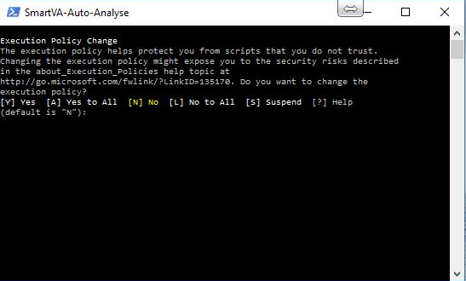

## Program Outputs – What does it do

### Screen Output

Assuming the configuration settings are correctly in place, once the program has begun, a progress bar will be updated to keep you informed of processing progress.

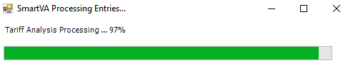

Upon completion, you will see a window displayed which will contain the results for all VA entries on the tablet. If there 5 results or less, you will see the results displayed in this format:

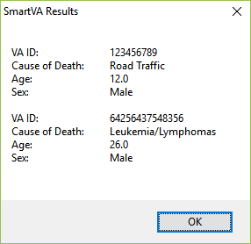

For cases where there are more than 5 to display to screen, the format changes slightly to allow more information to be output to the screen. This output also includes options to filter the results so that you can easily find a particular VA ID entry should you wish to. This screen looks as follows:

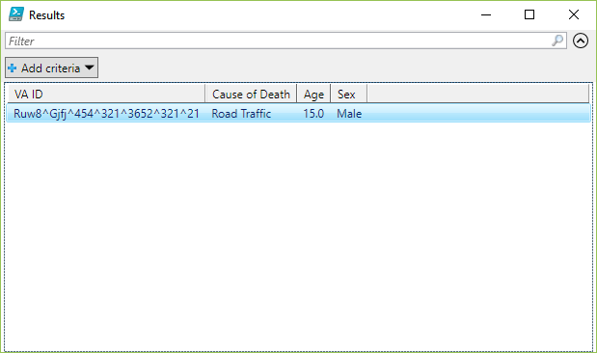

Simply Click **Ok**, or close the Results window when you have finished and the program will complete, ready for the next time you need to run it.

### File Outputs

#### Archive Folder

The archive folder is a location that is used to store two key pieces of information:

1. Copy of raw data from tablet once successfully processed
2. Results.csv file

Once the program has completed successfully, the underlying raw data for each result is copied to the archive, so that it can be used to perform future analysis as required (using the manual analysis method).

The archive folder location can be specified via the config.txt file (see Settings section for further information).

It should be noted that only data that has processed successfully will be copied to this archive, and therefore any errors in processing should be resolved to the point of successful program completion before any data is removed from the Tablet/Device.

#### Results.csv

In addition to the output to screen, the program also outputs the results to a file called **results.csv**. This file is located in the **Archive** folder, which can be found as a sub-folder of the location set in the config.txt file under ArchiveDir (see Settings information above for more information about locations).

For example, the default location for archiving, as configured in the config.txt file, is **C:\SmartVA**.

If you navigate to this folder, you will see a sub-folder called **Archive**, and within that folder is the file **results.csv**.

This file is useful if you need to review the results of previous analysis performed, or if you have closed the screen output and wish to review the results again. The screenshots below shows the file in the default location, and what its contents look like when opened in excel.

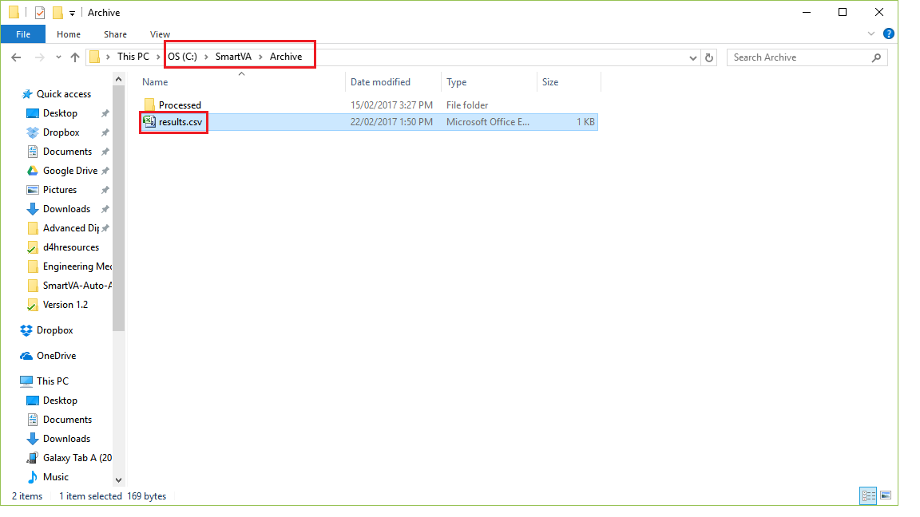

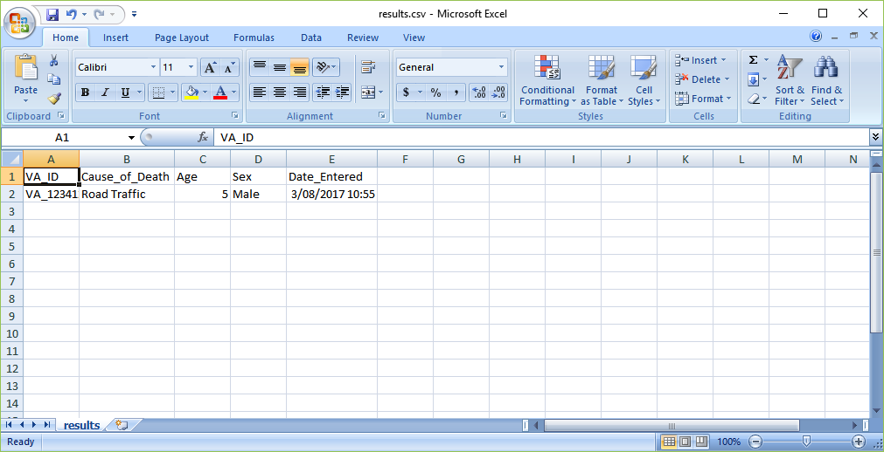

#### Log Files

When the program runs, all of the component parts (file copy from tablet, ODK Briefcase conversion & Tariff output) generate log files that can be reviewed if issues should arise. The **Logs** folder, contained within the **ProcessDir**, contains the following:

##### log.txt

This is the program log file and contains entries as each stage of the program runs/completes. Any error messages that are displayed to screen are also written to this file to aid with trouble-shooting. This log file should be checked first in case of any issues experienced.

##### adblog.txt

This log file contains information specific to the file copy from the tablet and can be used to further troubleshoot issues at this stage of the program run.

##### BriefcaseOutput.txt

This log file contains information specific to the ODK Briefcase conversion process and any issues with this stage of the program run will be logged here.

##### TariffOutput.txt

This log file contains the specific information relating to the Tariff analysis stage of the program run. Any issues experienced with Tariff analysis will be logged here.